In order to set up the EDI system to do inter-company data interchange, the Partners / File locations need to be set in the manner shown in the following example: For this exercise we will set up two partners with their respective file locations. Extrapolate this example should you be setting multiple companies’ data interchange.

- Set up both File locations, using the EDI menu option EDI – 3 - 14. For inter-company EDI the second page of each file location setup is left blank since no Value Added Network (VAN) communications exchange is required. You will note that these file locations are similar with the following exceptions:

- The input for File Location GTRENTFG is the output for File Location GTRENTAB
- The output for File Location GTRENTFG is the input for File Location GTRENTAB

- In the following two examples we are setting up file locations GTRENTFG and GTRENTAB.

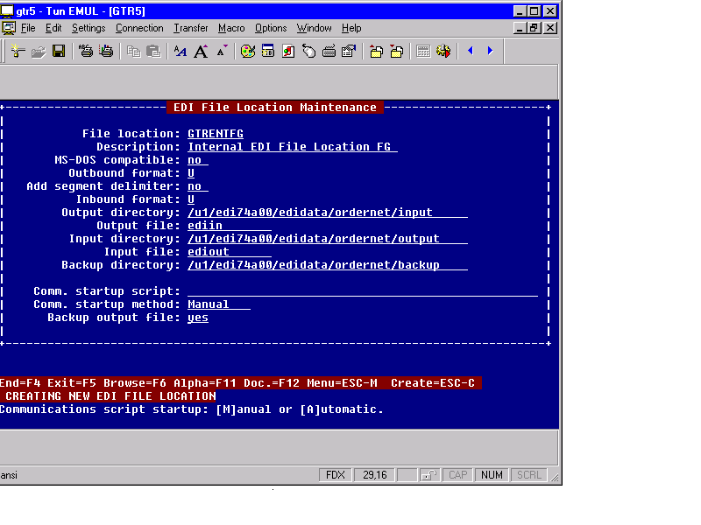Example 1: File location GTRENTFG

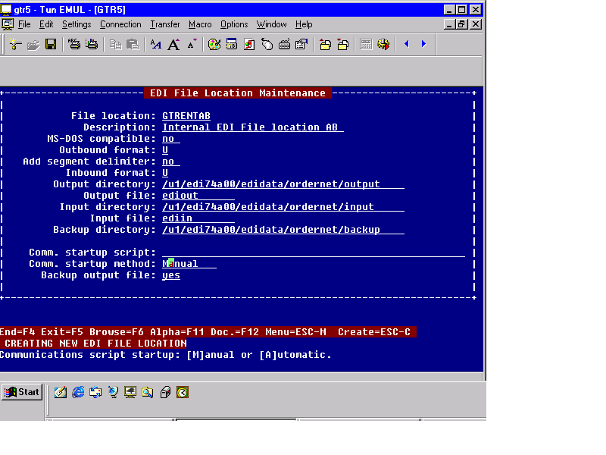Example 2: File location GTRENTAB
- Set up the Partners, using the EDI option EDI – 3 - 2.

You will note that the partner setups are similar with the following exceptions:

- The Inter. Envelope Partner for partner GTR-INTERNAL-FG is the User Id for partner
GTR-INTERNAL-AB
- The User Id for partner GTR-INTERNAL-FG is the Inter. Envelope Partner for partner
GTR-INTERNAL-AB

- In the following three screen examples we have set up partner GTR-INTERNAL-FG

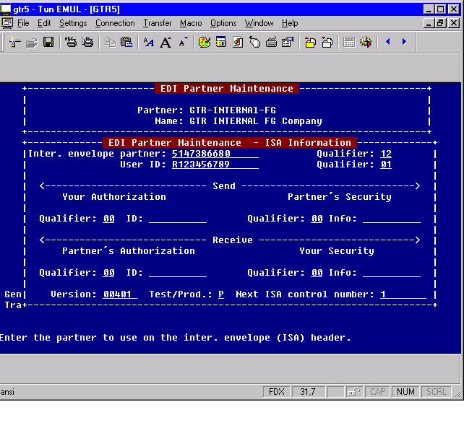Example 1: Partner GTR-INTERNAL-FG ISA set up screen
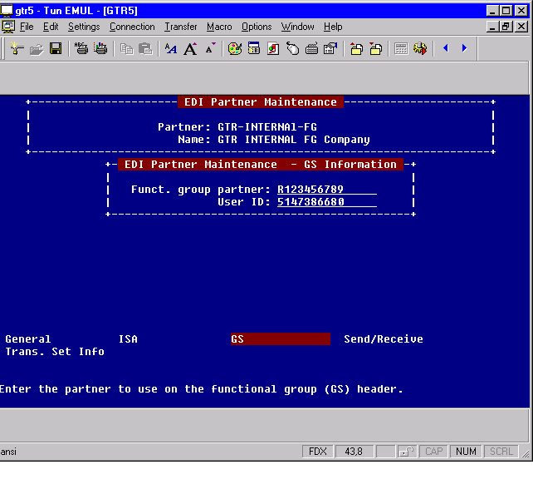Example 2: Partner GTR-INTERNAL-FG GS set up screen

Example 3: Partner GTR-INTERNAL-FG Send/Receive set up screen
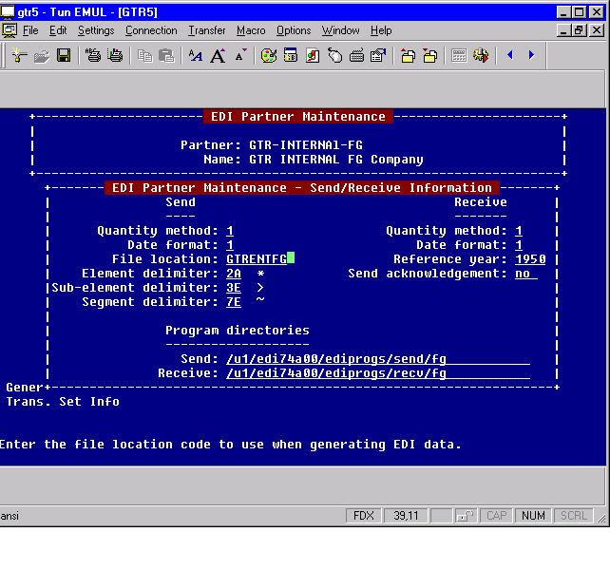

- In the following three screen examples we have set up partner GTR-INTERNAL-AB

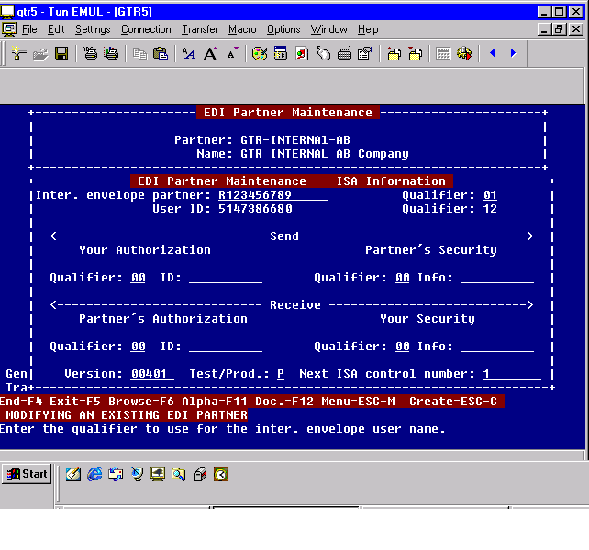Example 1: Partner GTR-INTERNAL-AB ISA set up screen
Example 2: Partner GTR-INTERNAL-AB GS set up screen
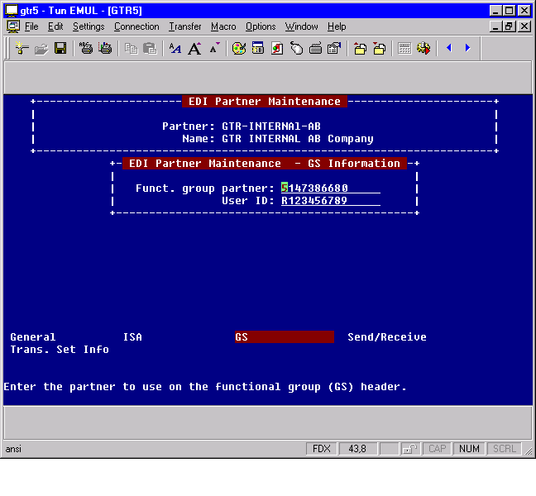
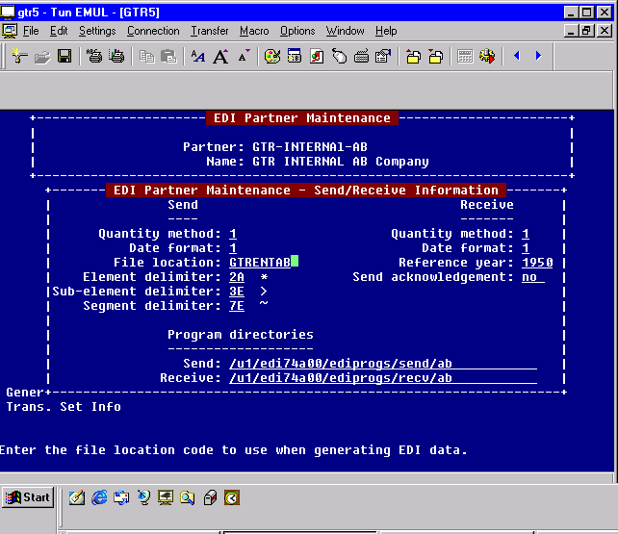Example 3: Partner GTR-INTERNAL-AB Send/Receive set up screen

